**ROAD ACCIDENT DASHBOARD**

This project focused on developing an interactive dashboard to analyze and visualize road accident data effectively. The work involved extensive data cleaning and preparation to ensure accuracy and consistency. Pivot tables were utilized to summarize and categorize the data, while new features were created to highlight key insights. Relationships between various features were established to make the data more intuitive and accessible. The final dashboard provides a clear, comprehensive view of accident trends, patterns, and contributing factors, supporting better understanding and informed decision-making.

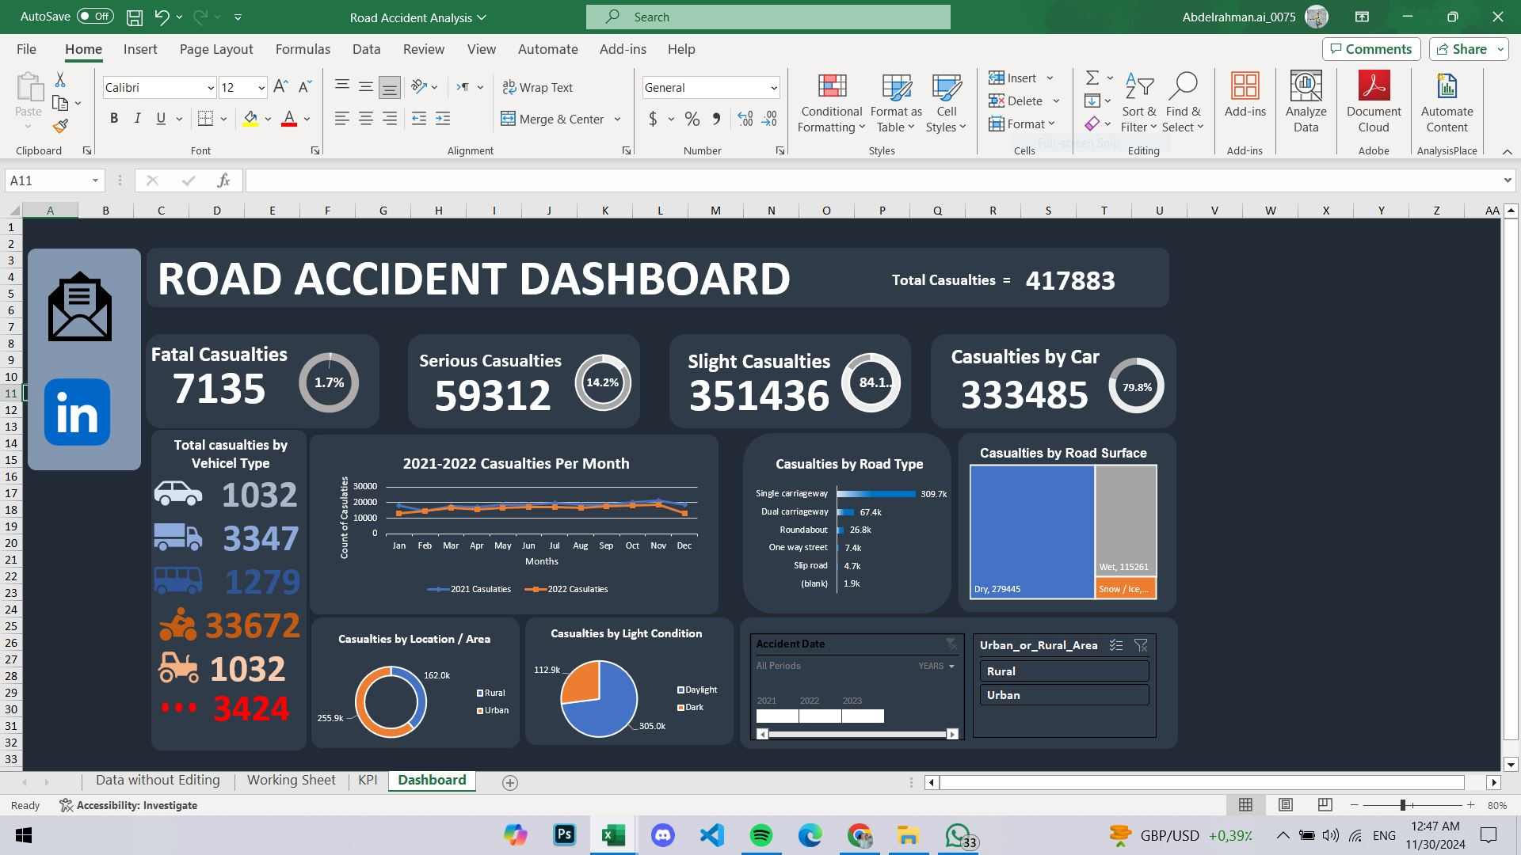

Let me know if you need any modifications!

**I do four sheets in this excel file:**

* **The first sheet has the real data without any cleaning or modification.**
* **The second sheet has the data after the preparation and make new feature in this data and Correct spelling errors in the data.**
* **The third sheet has many of pivot table that I do to make relationships between different columns to make the data more clear and more understandable.**
* **The fourth sheet in this sheet I do data visualization and many tools to make the data More clear and can help you to answer any questions about the data with easily.**

**The data without any preparation:**

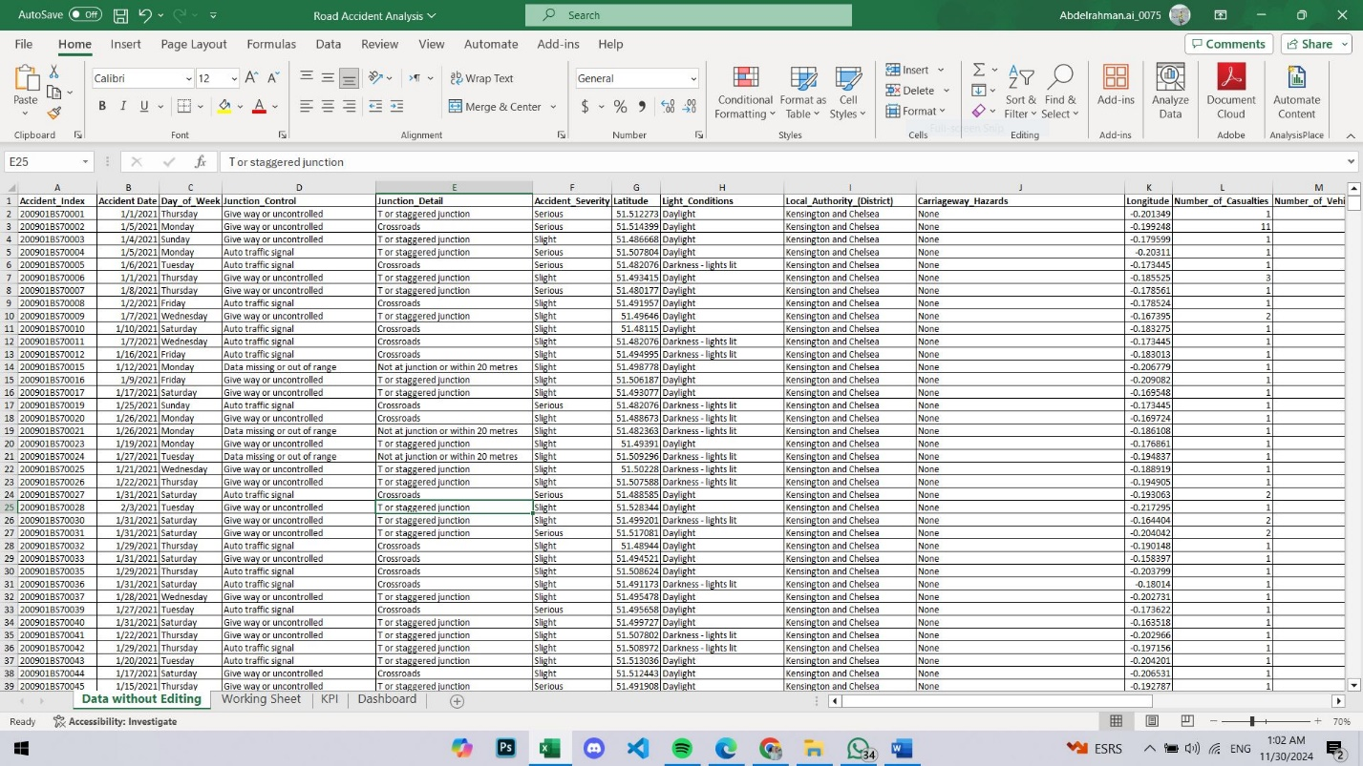

**The data after the preparation and cleaning:**

